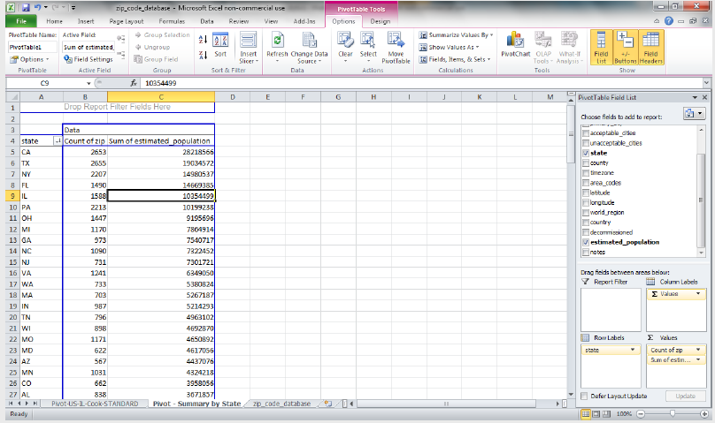

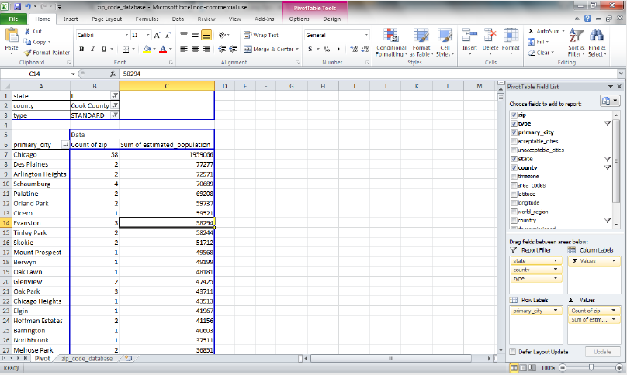

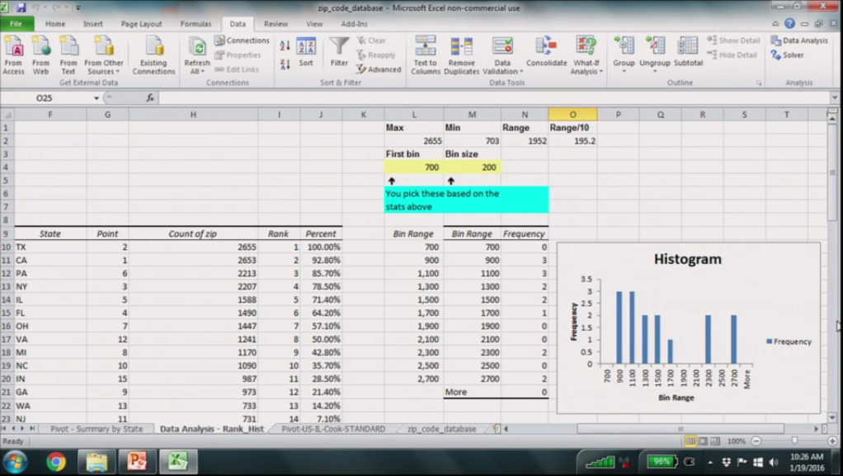

Create pivot table using US zip code data:

a)What characteristics are there e.g., exceptions, boundary definitions, history

b)How many postal designations are there for the country? Total zipcodes

c)What geographic area has the most postal codes? State and Naperville

HW:

1. Intro: ZIP; route; type; decommissioned;
2. Total zip codes filter by type and decommissioned;
3. Total zip codes filter by country.
4. State
5. naperville